Client / Owner: | C/O Lori Pearce
Contractor: | C/O Lori Pearce
Project Materials: | N/A

Pretium was on site to review work in progress and completed to date. Only items visible at the time of the site visit and at locations outlined below have been reviewed. The following was observed / discussed:
Location of Review
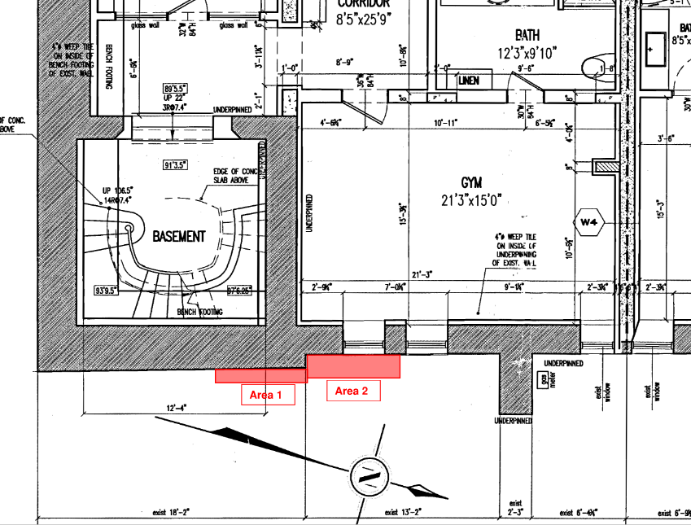

- Field Review Notes
- 2 adjacent excavations have been completed too-date.  - Area 1 (see plan drawing above) was first excavated over the previous days.  - Area 1 (Yellow Arrow) was first excavated, and at the time of this visit, a bench footing was already poured to encapsulate the original stone foundation. (see item 1.4 below)  - Area 2 (Red Arrow) was excavated to the base of the previously installed underpins. | 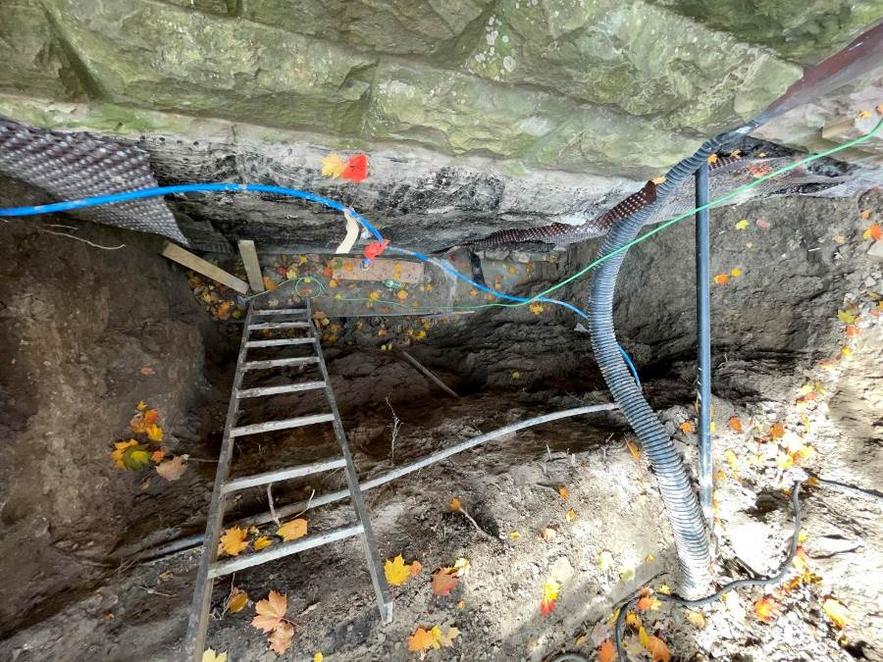
Close up of Area 1. (Facing South)  - Contractor was advised to leave bearing soil condition undisturbed under the existing footing (for the Bench footing condition). Based on the image taken, the work appears to have slightly impacted the bearing soil. | 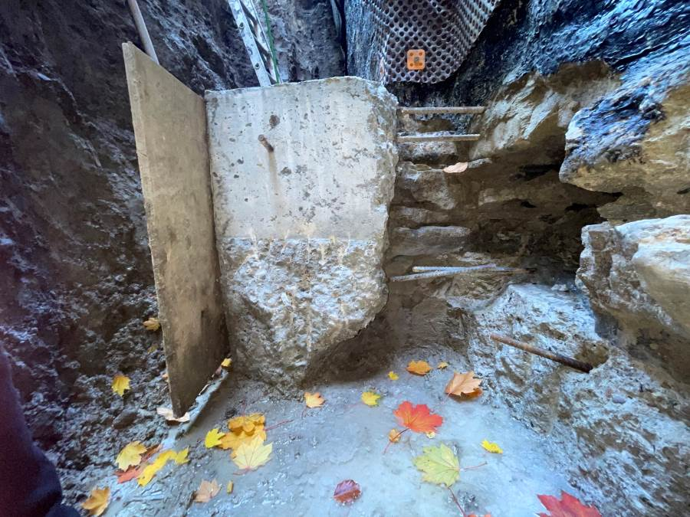
Area 2: Facing North  - It is Pretium’s understanding that the underpins will be extended just beyond the existing stone footing - to stabilize the stone footing for Area 2- connecting to the bench footing of Area 1 - to provide a continuous, stable substrate to extend the waterproofing down to the lower interior weeper level. | 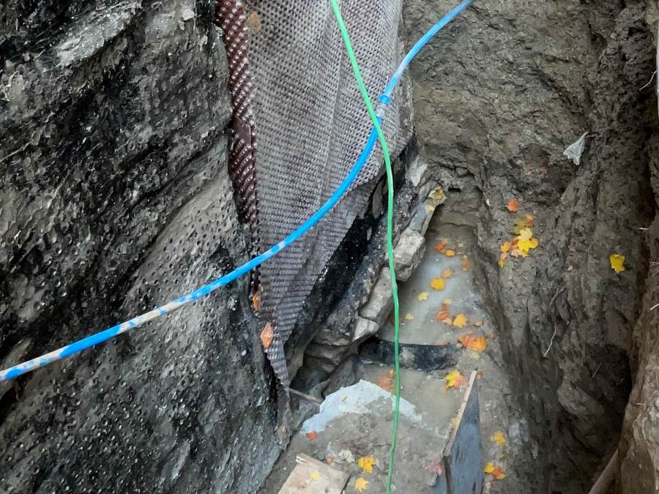
- This area (Area 2) has been excavated exposing the back-side of the previously installed underpinning.  - The bearing soil at the base of this footing did not appear to be disturbed.  - A close-up photograph shows the trough-wall weeper connection and underlying (short) underpins at excavation Area 2.  - Underpins are expected to be poured later today. | 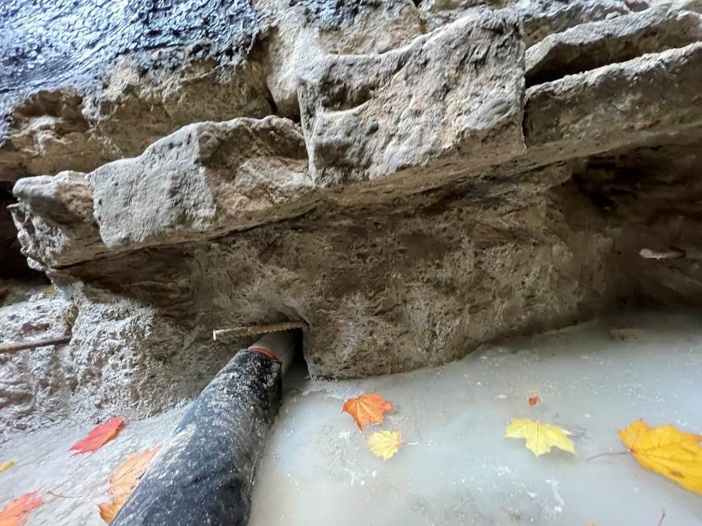
  - Once concrete is poured and set, and after forms are stripped, the through wall weeper connection must be made. A properly sloped exterior weeper is recommended, installed in a gravel bed protected with filter fabric.
  - Waterproofing membrane (suitable for green concrete) and drainage board are necessary to protect the foundation wall and to promote drainage to the weeping system.
  - Exterior insulation may help reduce thermal losses and protect the masonry from freeze-thaw cycling, however interior insulation is understood to be the primary insulation system.
  - It is understood that the interior weeper has been tested and confirmed to be draining properly.
  - If the interior weeper is of concern, as an additional protection, an interior sump and pump may be prudent.

This report was issued to all parties on November 7, 2026.
Trade foreman was verbally notified of report contents. This report pertains to work specifically requested and comments only on operations and items that were visible or being undertaken at the time of our inspection.
Report by: | John Pogacar, P.Eng

